Grappling Hubble (2009)Exploring Satellites

Every minute of every day, satellites orbit around the earth sending images and information back home. In this activity we will investigate the location and view of some of NASA’s satellites.



NASA has several satellites orbiting the earth including the Hubble Telescope, the Chandra X-Ray Observatory, and several National Oceanic and Atmospheric Administration (NOAA) satellites.

For each satellite below, find out

* 1. What is the measure of the arc of the great circle (such as the equator) that the telescope can measure?
  2. What is the measure of the viewing angle of the satellite ( $∠BSA$ in the diagram).
  3. How many kilometers of the great circle can the telescope measure?

1. The Hubble Telescope is 563km above the earth.

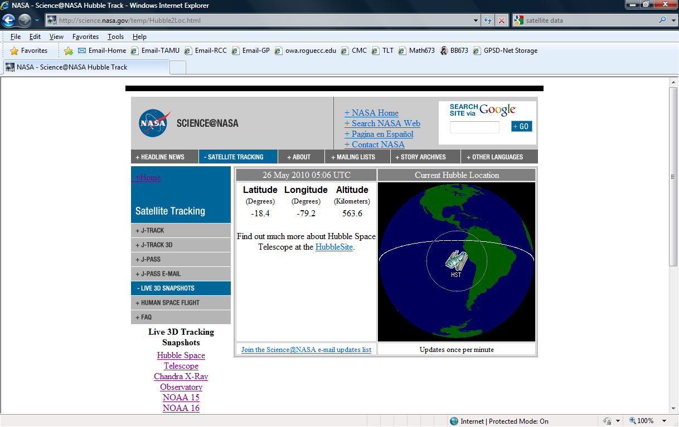

1. The Chandra X-Ray Observatory is 132,054 km above the earth

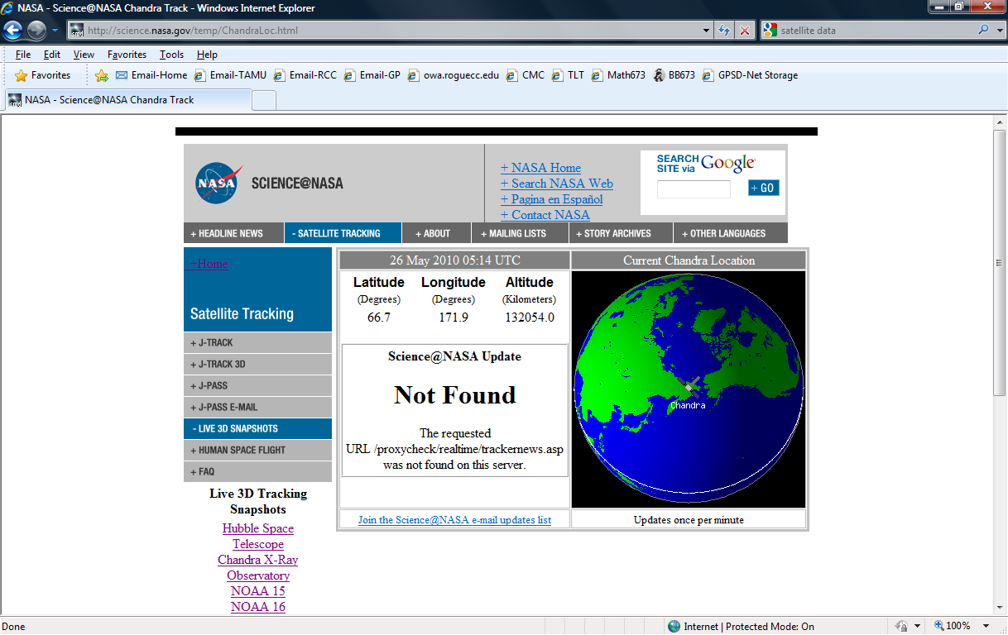

1. NASA Global Hydrology and Climate Satellite: NOAA 16 is at 826.6 km

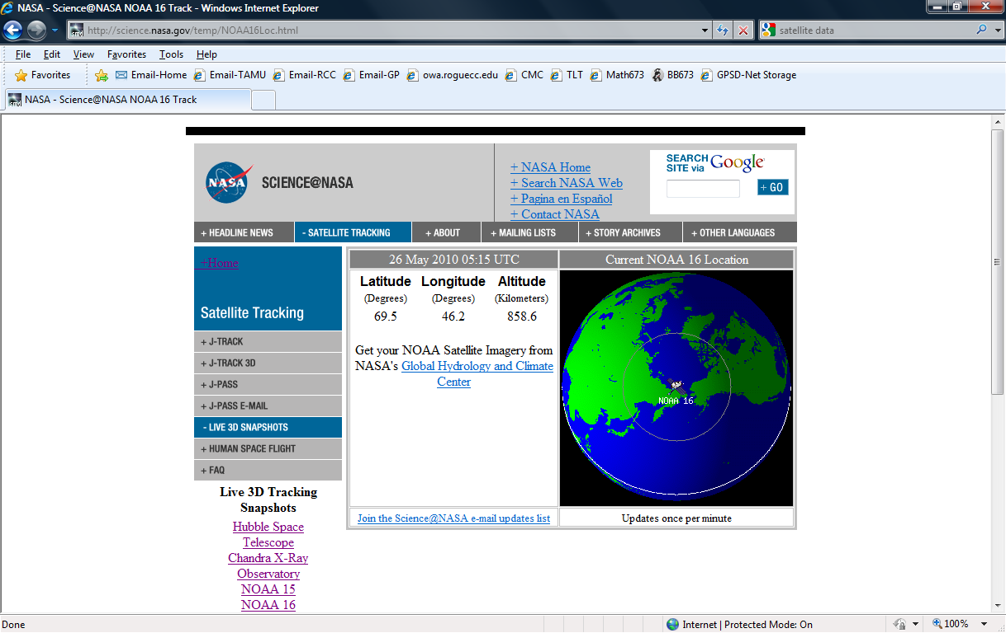

*Links:*NASA satellite image site: <http://www.ghcc.msfc.nasa.gov/GOES/>   
NASA satellite tracking: <http://science.nasa.gov/realtime/>