Exploring Piecewise Functions
Sometimes a simple function is sufficient for an application, but often the type of function needed changes over a given domain. This is when we need a piecewise function to allow us to “glue” several functions together to make one function. Let’s see how this works.

Cutting Graphs
- Begin by graphing the following functions on three separate graphs.

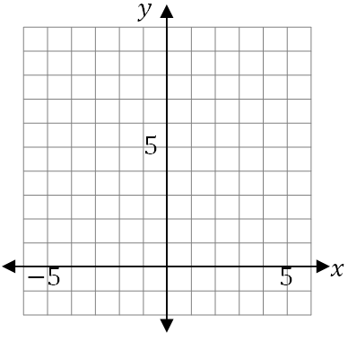
A) $y=-x$ B) $y=2$ C) $y=\frac{1}{2}x^{2}$

- Now cut out each square graphing grid.
- Cut each grid on the given vertical lines and discard the portion described.
  - Cut graph (A) on the vertical line $y=-2$ . Keep the left section and discard the right section. Draw a closed dot on the right end of this graph.
  - Cut graph (B) on the vertical lines $y=-2$ and $y=1$. Keep the middle section and discard the left and right sections. Draw an open dot on the far left side of the graph and a closed dot on the far right side of the graph.
  - Cut graph (C) on the vertical line $y=1$. Keep the right section and discard the left section. Draw an open dot on the far left of this graph.
- Now tape the remaining three pieces together to make one graph lining up the $x$-axis to show the entire domain $-6<x<6$.

You have now “pieced together” the graph of the piecewise function

$$y=\left\{\begin{matrix}-x, & if x≤-2 \\ 2, & if-2<x≤1 \\ \frac{1}{2}x^{2}, & if x>1\end{matrix}\right.$$

The key to graphing a piecewise function is to “cut” the graphs by vertical lines to end up with the correct graph made of these vertical slices.

